

\

**Traffic sign recognition using OpenCV & AI**

***Software development for an Intelligent Autonomous Vehicle Course***

Student's Name: Matan Shrazki ID: 206036063

Student's Name: Koral Tayeb ID: 207423757

**Submitted by:**

**התכנית לתואר ראשון B.Sc. במדעי המחשב**

**תוכן עניינים**

**1.** **הקדמה** 2

**1.1.** **תקציר** 2

**1.2.** **הפרויקט – Real Time Appearance – Based Mapping** 2

**1.3.** **מה למדנו בקורס זה?** 2

**1.4.** **מבוא** 2

**1.5.** **Data Visualization**

**1.6.** **Slam** 4

**1.7.** **Global loop closure detector**

**1.8.** **Conclusions** 4

**1.9.** **ביבליוגרפיה** 5

# **Introduction**

# **Abstract**

Traffic Sign Recognition (TSR) is used to regulate traffic signs, warn a driver, and command or prohibit certain actions. A fast real-time and robust automatic traffic sign detection and recognition can support and disburden the driver and significantly increase driving safety and comfort. Automatic recognition of traffic signs is also important for automated intelligent driving vehicle or driver assistance systems.

In this era of Artificial Intelligence, humans are becoming more dependent on technology. With the enhanced technology, multinational companies like Google, Tesla, Uber, Ford, Audi, Toyota, Mercedes-Benz, and many more are working on automating vehicles. They are trying to make more accurate autonomous or driverless vehicles. You all might know about self-driving cars, where the vehicle itself behaves like a driver and does not need any human guidance to run on the road. This is not wrong to think about the safety aspects—a chance of significant accidents from machines. But no machines are more accurate than humans. Researchers are running many algorithms to ensure 100% road safety and accuracy.

When you, as a driver, go on the road, you see various traffic signs like traffic signals, turn left or right, speed limits, no passing of heavy vehicles, no entry, children crossing, etc., that you need to follow for a safe drive. Likewise, autonomous vehicles also must interpret these signs and make decisions to achieve accuracy. The methodology of recognizing which class a traffic sign belongs to is called Traffic signs classification.

In this Deep Learning project, we will build a model for the classification of traffic signs available in the image into many categories. This project presents a study to recognize traffic sign patterns using Convolutional Neural Network (CNN)* and Keras** models. The Neural Networks stages are performed to recognize the traffic sign patterns. The system is trained and validated to find the best sign fit and introduce it to the user. The experimental results show the highly accurate classifications of traffic sign patterns.

*Convolutional Neural Networks - A convolutional Neural Network is a Deep Learning network used to pick up features from the image. Initially, they take the input images and then find out the lines, gradients, shapes, and borders from the image.

**Keras is an open-source deep learning framework written in Python. It provides a high-level interface for building and training neural networks. Keras is known for its user-friendly and modular design, which allows developers to quickly prototype and experiment with different network architectures. In Keras, a model represents the architecture of a neural network. It is typically composed of multiple layers, which are stacked on top of each other to form a computational graph. Each layer in the model performs specific computations on the input data and passes the results to the next layer.

# **Challenges**

Highly efficient algorithms and powerful performance hardware are required in the system. Furthermore, the environment constraint included lighting, shadow occlusion, air pollution, weather conditions (sunny, rainy, foggy, etc.) as well as the additional image distortions, such as, motion burl, vehicle vibration, and abrupt contrast changes possibly occur frequently in the actual system. The main objective is to reduce the search space and indicate only potential regions for increasing the efficiency and speed of the system. A higher robust and faster intelligent algorithm is required to provide the necessary accuracy in recognition of traffic signs.

# **Inspirations**

In recently studies, the detection and recognition of traffic signs have been developed in many research centers. A vision system for the traffic sign recognition and integrated autonomous vehicle was developed in part of European research project PROMETETHEUS at DAIMLER-BENZ Research Center [1]. Moreover, many techniques have been developed for road sign recognition, for example, Pacheco et al. [2] used special color barcodes under road sign for detecting road sign in vision-based system. This took a lot of time and resources. Genetic algorithm was also proposed by Aoyagi and Askura [3] to identify road sign from gray-level images, but the limitation of crossover, mutation operator, and optimal solution are not guaranteed.

# **Strategy**

The Traffic Sign Recognition Systems usually have developed into two specific phases. The first is normally related to the detection of traffic signs in a video sequence or image using image processing. The second one is related to recognition of these detected signs, which is deal with the interest of performance in artificial neural network. The detection algorithms normally based on shape or color segmentation. The segmented potential regions are extracted to be input in recognition stage.

The efficiency and speed of the detection play important role in the system. To recognize traffic signs, various methods for automatic traffic sign identification have been developed and shown promising results. Neural Networks precisely represents a technology that used in traffic sign recognition. The difficulties of traffic sign detection and recognition are involved with the performance of system in real time.

# **Implementation**

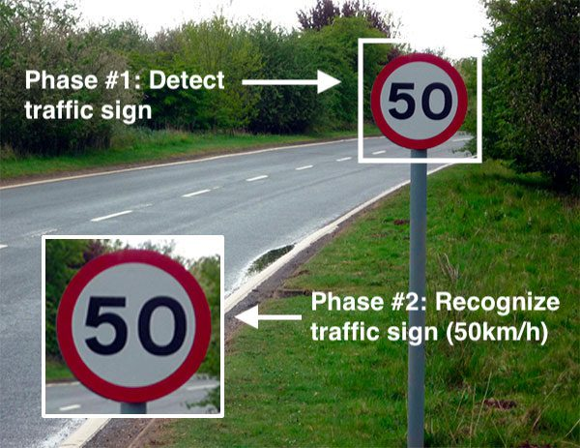

# **Bibliography**

א. https://app.theconstructsim.com/#/Home

ב. https://towardsdatascience.com/ros-autonomous-slam-using-randomly-exploring-random-tree-rrt-37186f6e3568

ג. https://www.youtube.com

ד. http://introlab.github.io/rtabmap/#:~:text=The%20loop%20closure%20detector%20uses%20a%20bag-of-words%20approach,graph%20optimizer%20minimizes%20the%20errors%20in%20the%20map.

# 